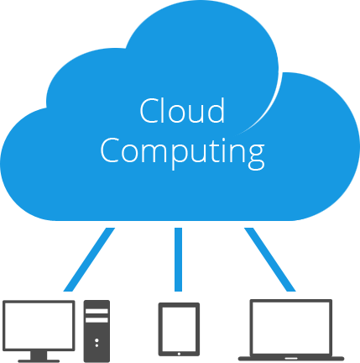

STUDENT: STÉPHANE DÍAZ-ALEJO LEÓN
GROUP: 1E1
EXERCISE 1

Define the concepts related to cloud and cloud computing. Enumerate advantages and drawbacks of this model. Describe the different solutions given by the market.

CLOUD COMPUTING
Cloud computing is a comprehensive solution that delivers IT as a service. It is an Internet-based computing solution where shared resources are provided. Computers in the cloud are configured to work together and the various applications use the collective computing power as if they are running on a single system.
The flexibility of cloud computing is a function of the allocation of resources on demand. This facilitates the use of the system's cumulative resources, negating the need to assign specific hardware to a task. Before cloud computing, websites and server-based applications were executed on a specific system. With the advent of cloud computing, resources are used as an aggregated virtual computer. This amalgamated configuration provides an environment where applications execute independently without regard for any particular configuration.
There are three different kind of cloud computing, where different services are being provided for us:
- IaaS (Infrastructure as a Service): A computer infrastructure, such as virtualization, being delivered as a service. IaaS is popular in the data center where software and servers are purchased as a fully outsourced service and usually billed on usage and how much of the resource is used.
- PaaS (Platform as a Service): A computing platform being delivered as a service. Here the platform is outsourced in place of a company or data center purchasing and managing their own hardware and software layers.
- SaaS (Software as a service): A software delivery method that provides access to software and its functions remotely as a Web-based service. Software as a Service allows organizations to access business functionality at a cost typically less than paying for licensed applications since SaaS pricing is based on a monthly fee.

ADVANTAGES AND DRAWBACKS

Advantages:
- Lower upfront costs and reduced infrastructure costs.
- Easy to grow your applications.
- Scale up or down at short notice.
- Only pay for what you use.
- Everything managed under SLAs (an agreement between a client and the service provider).
- Overall environmental benefit (lower carbon emissions) of many users efficiently sharing large systems.

Drawbacks:
- Higher ongoing operating costs.
- Greater dependency on service providers.
- Risk of being locked into proprietary or vendor-recommended systems.
- What happens if your supplier suddenly decides to stop supporting a product or system you've come to depend on?
- Potential privacy and security risks of putting valuable data on someone else's system in an unknown location
- If lots of people migrate to the cloud, where they're no longer free to develop neat and whizzy new things, what does that imply for the future development of the Internet?
- Dependency on a reliable Internet connection.
MITIGATE THE RISK
With the use of systems in the cloud, there is the ever present risk of data security, connectivity, and malicious actions interfering with the computing processes. However, with a carefully thought out plan and methodology of selecting the service provider, and an astute perspective on general risk management, most companies can safely leverage this technology.

BIBLIOGRAPHY

https://www.esds.co.in/blog/cloud-computing-basic-concepts/#sthash.eGOSqco9.iUuHExop.dpbs

https://www.ibm.com/developerworks/cloud/library/cl-cloudintro/index.html

http://www.levelcloud.net/why-levelcloud/cloud-education-center/advantages-and-disadvantages-of-cloud-computing/

https://en.wikipedia.org/wiki/Cloud_computing

http://www.webopedia.com/TERM/C/cloud_computing.html

http://www.explainthatstuff.com/cloud-computing-introduction.html

https://www.cloudave.com/34670/top-cloud-computing-security-issues-solutions/

